ML Classification Report Explanation

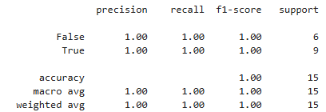

1. Precision:

What is Precision?
Precision indicates how many of the instances predicted as positive are actually positive.
It focuses on reducing false positives, which is critical in applications like spam detection and fraud detection.
- Formula:
Precision = TP / (TP + FP)
- 0 1.00
- 1 1.00

2. Recall:

What is Recall?
Recall measures how many actual positive instances were correctly identified by the model.
It focuses on reducing false negatives, which is important in medical diagnosis or safety systems.
- Formula:
Recall = TP / (TP + FN)
- 0 1.00
- 1 1.00

3. F1-Score:
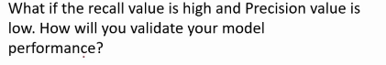

- Harmonic mean of precision and recall
- Best metric when data is imbalanced
- If recall is high and precision is low, it means the model is identifying most of the actual positive cases, but it is also producing many false positives.
- Formula:
F1 = 2 × (Precision × Recall) / (Precision + Recall)
- 0 1.00
- 1 1.00

4. Support:

What is Support?
Support represents the number of actual samples belonging to each class in the dataset.
It shows how much data was available to evaluate that class.
- 0 6
- 1 9

Accuracy 1.00:
- The model correctly classifies 87% of all samples
- Accuracy alone is not sufficient for imbalanced datasets, so other metrics are important

Macro Average:
- Precision: 1.00
- Recall: 1.00
- F1-Score: 1.00
- Treats both classes equally, regardless of sample size

Weighted Average:
- Precision: 1.00
- Recall: 1.00
- F1-Score: 1.00
- Takes class imbalance into account (more weight to class 0)

